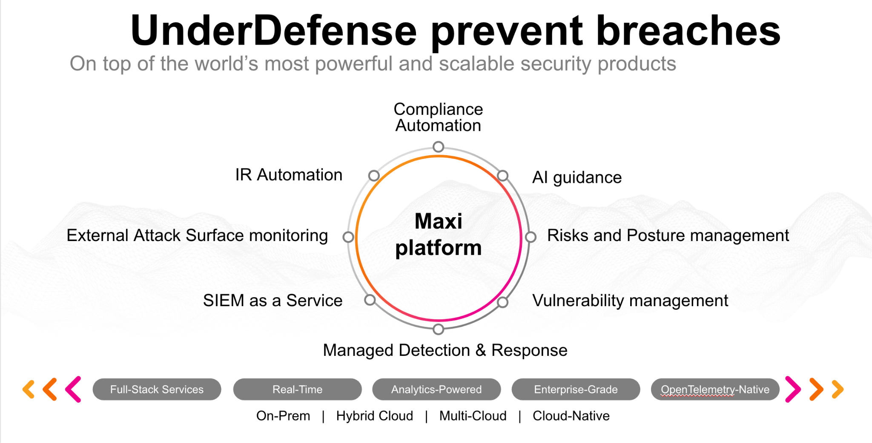**UnderDefense policy template kit**

Starting your compliance journey? UnderDefense policy template offers a comprehensive and compliance-ready document, complete with placeholders for company-specific details.

**How to use this document**

1. Thoroughly review the content of each policy, analyzing it section by section.
2. Evaluate whether the subsequent section and its associated risks are applicable to you. If it does not, remove it and/or replace it with your organization’s corresponding practices.
3. Replace any highlighted text in angled brackets < >[1] with appropriate information (Use Find to make sure that all text in angled brackets is replaced)
4. Remove this instructions page
5. Add any company-specific letterhead, branding, and formatting
6. Save this document as PDF and upload to UnderDefenseMAXI to <https://app.underdefense.com/compliance/ISO27001/approved-policies>

# 

# **The Path to Compliance**

# We'll guide you through, ensuring a smooth path to compliance:

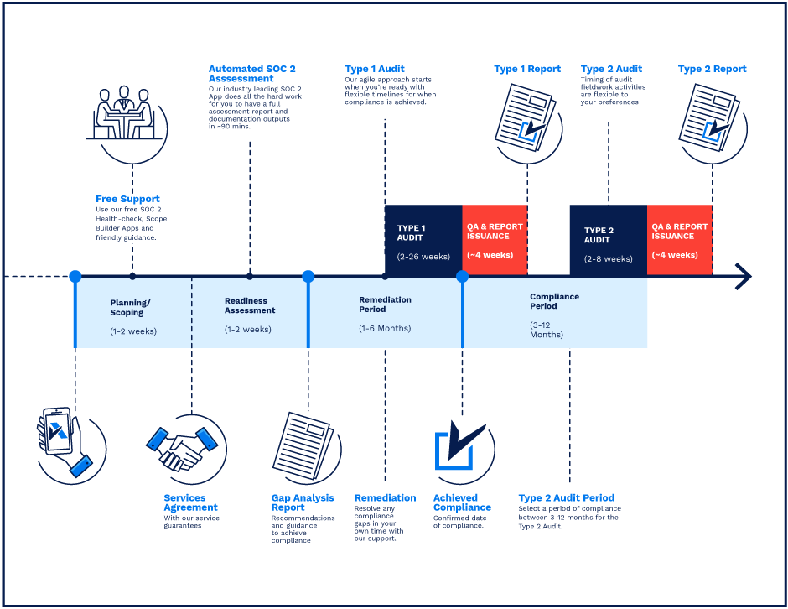

**SOC 2 Certification Timeline for SMBs with 50-250 Employees**

# 

# **Need Expert Assistance?**

| Navigating the complexities of compliance can be challenging, especially for businesses with limited internal resources or expertise.   * Experience team at the right time * Preparation of all compliance docs * Expert guidance on all tech-related issues   [**Book a call with expert**](https://meetings.hubspot.com/underdefense/help-with-compliance) | **Take your compliance from probable to guaranteed.** |
| --- | --- |

**<Your Company Logo>**

**Physical Media Transfer Policy**

# ***Version Control Table***

| Version | Date | Author | Description |
| --- | --- | --- | --- |
| 1.0 | <Date> | <Author> | Issued |
| 1.0 | <Date> | <Author> | Reviewed |
| 1.0 | <Date> | <Author> | Approved |
| **1.0** | <Date> | <Author> | **Granted “FINAL” status** |

| **Date of Next Revision** | **<date>** |
| --- | --- |

This policy will be reviewed for continued completeness, relevance, and accuracy within 1 year of being granted “final” status and at yearly intervals after that.

The version control table will show the published update date and provide a thumbnail of the significant change. CAUTION: the thumbnail is not intended to summarize the difference and is not a substitute for reading the full text.

# ***Table of Contents***

**The Path to Compliance 2**

**We'll guide you through, ensuring a smooth path to compliance: 2**

**Need Expert Assistance? 2**

**Version Control Table 4**

**Table of Contents 5**

**Purpose 5**

**Scope 6**

**Policy 6**

Contracted couriers and shipping companies 6

Process of courier ordering 6

Physical security of packages 6

Parcels traceability 7

**Disciplinary actions 7**

**Change, Review, and Update 7**

**Responsibility 7**

**Reference 7**

**Related Documents 7**

# 

# Purpose

The purpose of this policy is to define our secure standard of courier company selection and the fast process of media delivery to our locations (offices), customers, and vendors to protect media containing information against unauthorized access, misuse, or corruption during transportation.

# Scope

The scope of this policy includes all users who have access to company-owned or company-provided computers or require access to the corporate network and systems. This policy applies to employees and guests, contractors, and anyone needing access to the corporate systems.

# Policy

* To assure information security during physical media transfer the company has selected dedicated couriers and shipping companies.
* All conditions of delivery - including the security of packages - are prescribed in the signed contracts.

## Contracted couriers and shipping companies

The following companies are selected for the transfer of physical media:

* <Courier company> for couriers delivery - All routes and deliveries of couriers are owned, identified, and mapped, taking into account safety rules and risk location on regular routes, controlled by appropriate means of communication between the dispatcher and the driver on the road, controlled by the vehicle monitoring system during freight. Companies provide systematic control of the technical condition of vehicles. Drivers are highly qualified and have good driving experience.
* International delivery.

## Process of courier ordering

* All couriers are called by phone or using the courier company delivery registration system.
* As couriers are assigned to specific regions, areas, and streets, a dispatch from our office is done by known couriers. Couriers should have uniforms, a badge with a photo, and a personal identification number. Couriers drive cars with company logos.
* After calling the courier, an SMS arrives on the company phone indicating the name and phone number of the courier who will come to pick up the shipment.
* Storage of all post information.

## Physical security of packages

Depending on the contents, different packaging for parcels is used. Documents are put in non-see-through, waterproof, branded envelopes. Working equipment is packed in solid boxes using air-bubble film.

The following rules are applied for packing equipment and other large shipments:

* Choose only quality cardboard boxes without damage.
* Fix the contents of the box, leaving no voids and bulging sides.
* Tightly seal the box with tape.
* Properly mark the box with the basic information about the sender and recipient and contact details.
* Special rules apply for shipments with <Courier company>:
  + The marking must be printed clearly, without blurring the printed elements. Pale printing and the presence of unprinted areas on the label are not allowed;
  + The markings must be glued evenly, without jamming;
  + Don't mark corners of the box;
  + The marking must be seen on a box;
  + The marking must be firmly attached to the packaging to avoid tearing.

## Parcels traceability

When using <Courier company>, we receive an individual and unique number. We can track the parcel’s location, the approximate delivery time, and whether it was delivered to the recipient through the company account.

# Disciplinary actions

Employees who violate this policy may face disciplinary consequences in proportion to their violation. Management will determine how severe an employee’s offense is and take the appropriate action.

# Change, Review, and Update

This policy shall be reviewed once every year unless the owner considers an earlier review necessary to ensure that the policy remains current. Changes to this policy shall be exclusively performed by the ISMS Manager and approved by the ISMS Committee.

# Responsibility

This is the responsibility of the ISMS Manager to maintain and make sure everyone is aware of this policy.

# Reference

* ISO 27001 Annex A.8.3.3 Physical Media Transfer

# Related Documents

1. All fields in this document marked by angled brackets < > and highlighted must be filled in.